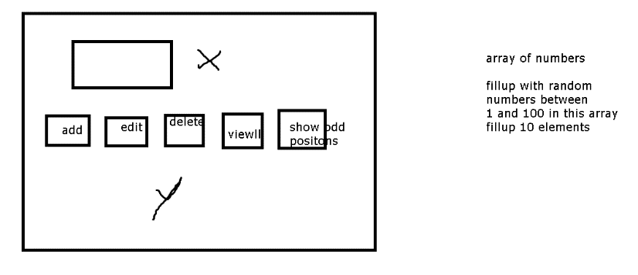

1. There is a predefined array of numbers of size 10.
2. All buttons disabled in the beginning
3. Event
   1. On blur on the textbox
      1. Check the number whether it is present in the array or not
      2. If present
         1. Enable the buttons
            1. Edit
            2. Delete
         2. Disable the button
            1. Add
            2. View all
            3. Show odd positions.
      3. If not present
         1. Enable only add button
   2. When add button is clicked
      1. Check in the array if number is present or not present
      2. If not present
         1. Add to the array
         2. Disable all the buttons
      3. If present
         1. Don’t add to the array
         2. Disable all buttons
   3. When edit button is clicked
      1. Use a prompt function from window object which will give you a number.
      2. Replace the old number with the new number provided new number does not exist
   4. When delete button is clicked
      1. Remove the number from the array.
   5. When view all is clicked
      1. Show the entire array in the region Y
   6. When we click on show odd positions in the array
      1. Show only the numbers which are in odd position 0, 1, 3, 5,7,9
4. While all doing this show appropriate messages in X

Assignment 2

1. Onblur
   1. Empno
   2. Check in the array if empno is found, if found
      1. Modify
      2. Remove
   3. If empno not found
      1. Enable add button
2. ….. see the first program, do similar things
3. When we click on deptid
   1. Show all employees belonging to the deptid --Y region
   2. In X region keep updating it with the messages

3rd Assignment

A07item.html

1. Add a add button
2. When we click on it
   1. Whatever items details are entered add to the array in the Logic
   2. But ensure that itemno is unique
   3. Show appropriate messages
   4. Update the rows that come below all the buttons to show newly added item.

4th Assignment

1. Make a copy of the second assignment and write classes to make logic and event handling separate , look at we did with a07item.html and follow a similar approach.